PROJECT BY TEJVIR, ROGER, MOHAMMAD

# CREATION OF TABLES:

# C:\Users\Apple\AppData\Local\Microsoft\Windows\INetCache\Content.Word\table1.PNG

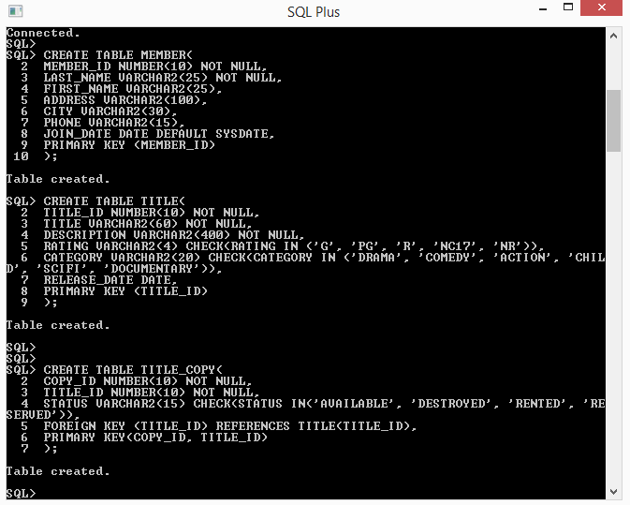

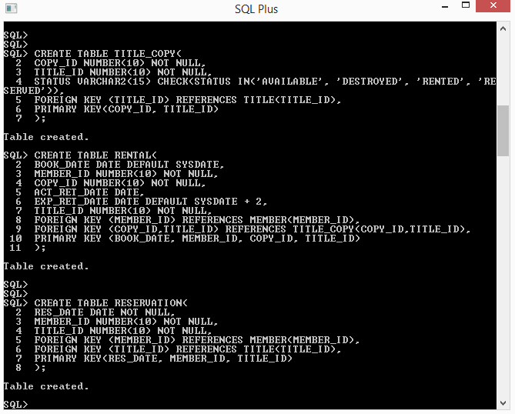

# CHECKING THAT TABLES AND CONSTRAINTS ARE CREATED:

# C:\Users\Apple\AppData\Local\Microsoft\Windows\INetCache\Content.Word\check.PNG

# CREATING SEQUENCES AND VERIFYING THEM:

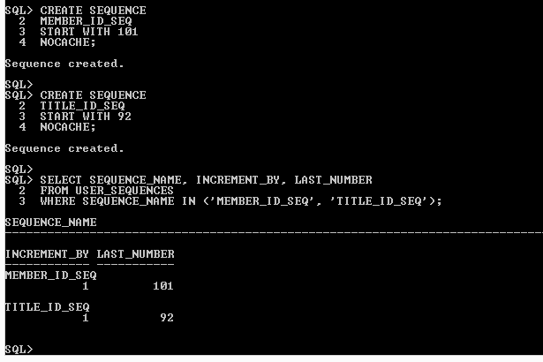

# INSERTING DATA INTO MEMBER:

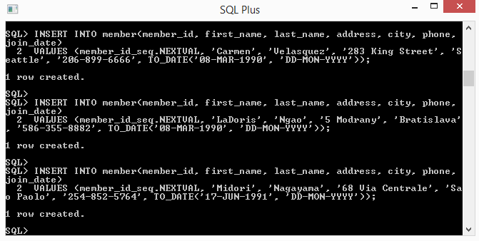

# INSERTING DATA INTO TITLE:

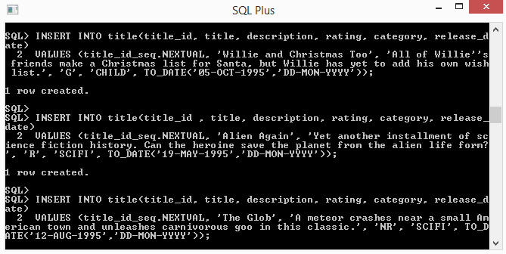

# INSERTING DATA INTO TITLE_COPY:

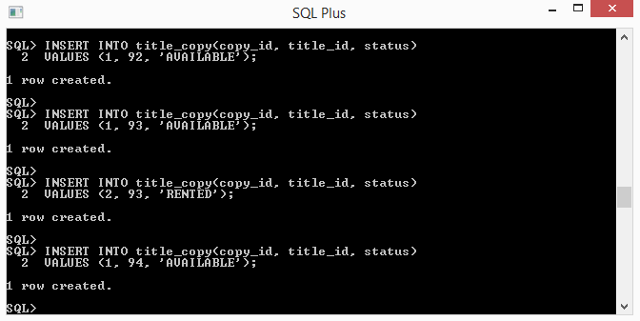

# INSERTING DATA INTO RENTAL:

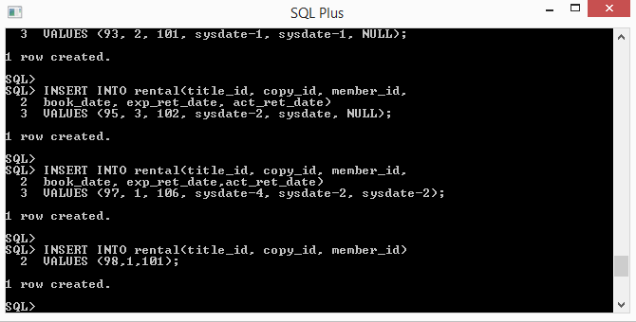

# INSERTING DATA INTO RESERVATION:

# C:\Users\Apple\AppData\Local\Microsoft\Windows\INetCache\Content.Word\INSERT RESERVATION.PNG

# DATA OF MEMBER:

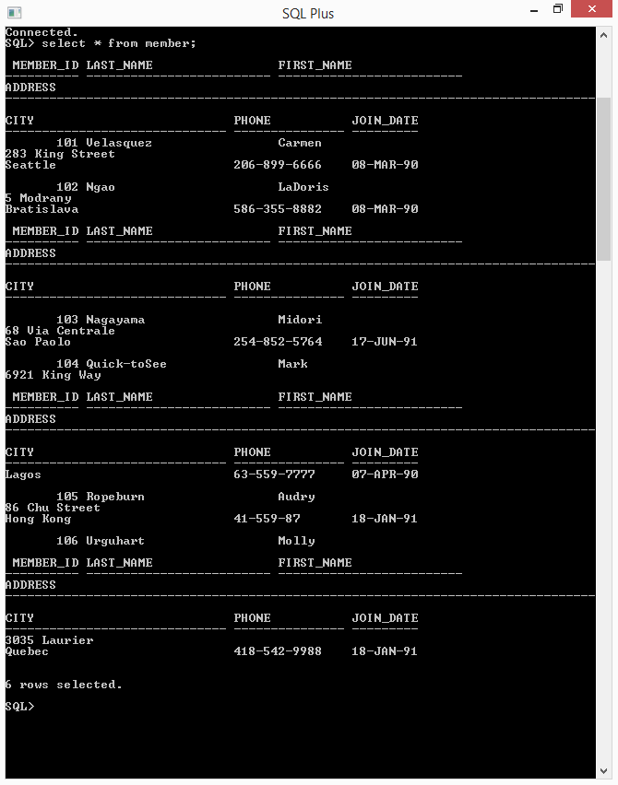

# DATA OF TITLE:

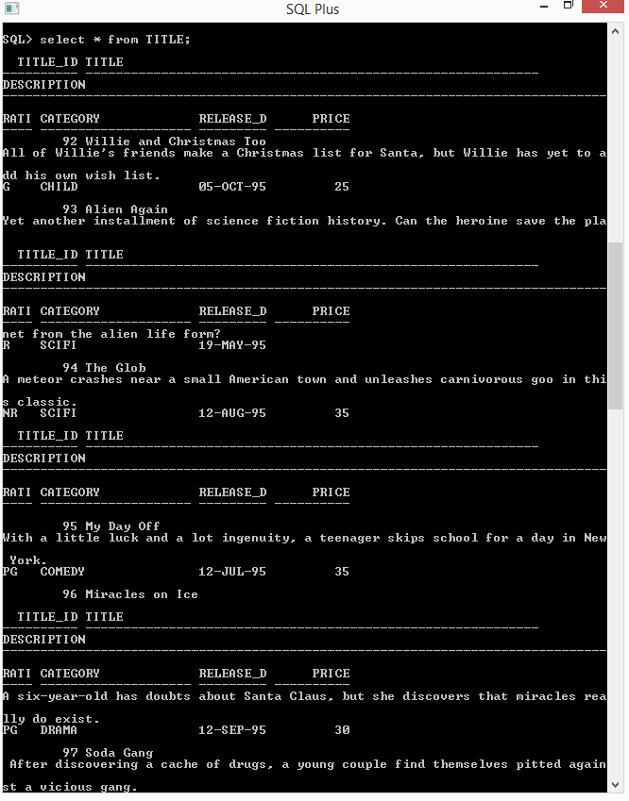

# DATA OF TITLE_COPY:

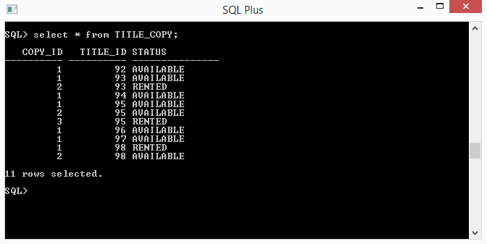

# DATA OF RENTAL:

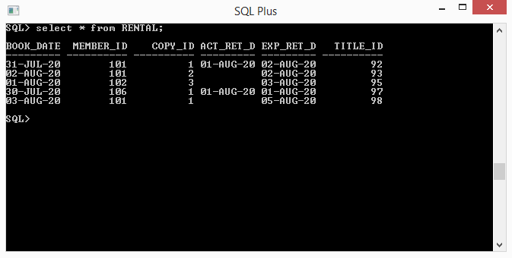

# DATA OF RESERVATION:

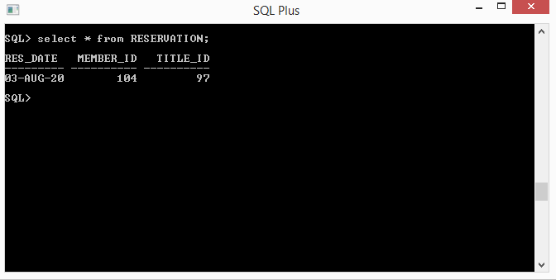

# CREATING VIEW:

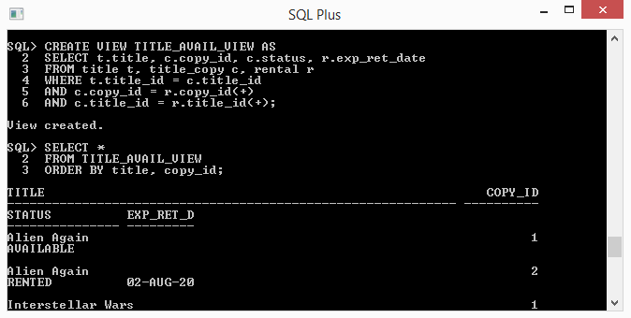

# REMOVING RESERVATION:

# C:\Users\Apple\AppData\Local\Microsoft\Windows\INetCache\Content.Word\REMOVE RESERVATION.PNG

# ADDING A RENTAL:

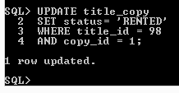

# PROOF FROM VIEW THAT INTERSTELLER MOVIE IS NOW UPDATED TO RENTED:

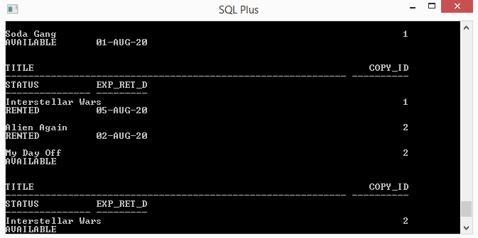

# ADDING PRICE COLUMN:

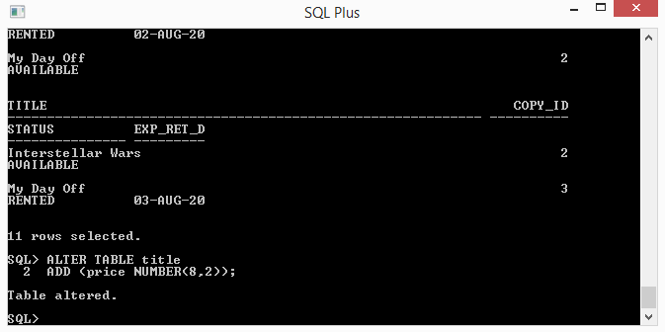

# VERIFYING PRICE COLUMN:

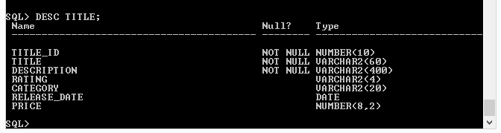

# ADDING PRICES

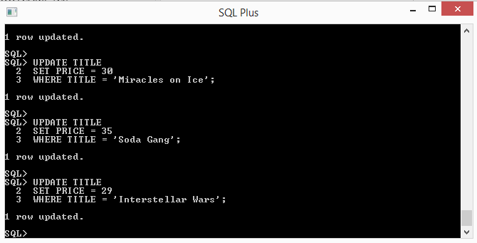

# VERIFYING THAT PRICES WERE ADDED:

